**Brand Library & Art Center Porch and Plaza Photography Permit**

**Fee: $100.00 per hour**

Make checks payable to *City of Glendale.*

This permit grants the applicant access to the Brand Library porch and plaza and paved areas around the brand Library building at the date/time specified below. (see site map on reverse.)

RESTRICTIONS: Access to library entrances and parking may not be blocked during the library’s regular hours or during special events.

_____________________________________________________________________________________________

DATE AND TIME REQUESTED:

______________________________________­­­­­­­­­­­­­­­­­­

NAME:

ADDRESS:

City: _____________________________________ STATE: ____________ ZIP:

PHONE: _______________________________ ALTERNATE PHONE:

email:

NOTES:

For photography in the park, including grass areas, a permit must be arranged with the Glendale Community Services and parks department: 818-548-2184.

_____________________________________________________________________________________________

**INTERNAL USE ONLY**

APPROVED BY: ______________________________________ Date: __________________________________

ENTERED IN CALENDAR: __________________________

mETHOD OF PAYMENT: ________________________________________________________________________

date processed: _______________________ receipt/transaction no.: _____________________________

_____________________________________________________________________________________________



Brand Library & Art Center

1601 W. Mountain St.

Glendale, CA 91201

818-548-2051

info@brandlibrary.org

Hours: Tuesday-Thursday 11am-8pm | Friday-Saturday 10am-5pm

**Brand Library & Art Center Site Plan**

**AREAS COVERED BY BRAND LIBRARY & ART CENTER PORCH AND PLAZA PHOTOGRAPHY PERMIT**

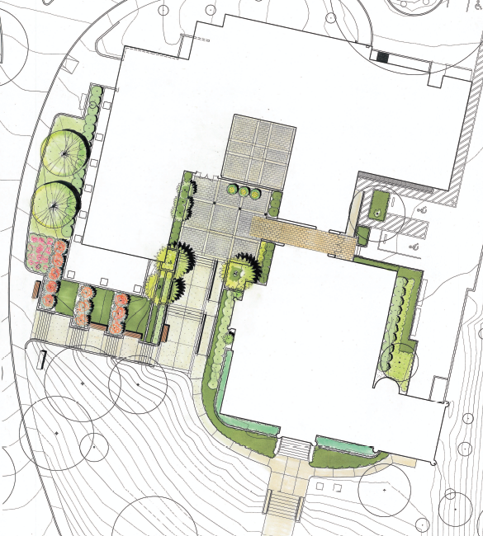

**Brand Library**

**Brand Library Art Galleries and Recital Hall**